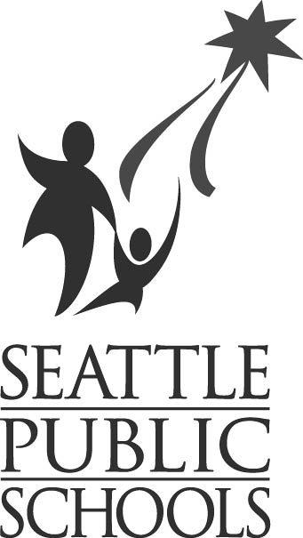GARFIELD HIGH SCHOOL

SEATTLE SCHOOL DISTRICT BUILDING EXCELLENCE
DESIGN UP-DATE FACT SHEET, MARCH 31, 2004

TEACHER DESIGN FEATURES
Garfield High School Design Features:
- The new design contains the same number of core classrooms (Math, Language Arts and Social Studies Classrooms) as the current Garfield building including the portables.
- The new design will have classrooms that average 850 square feet. The current average size is approximately 550 square feet.
- The new design will have offices for teaching staff. Currently most teachers do not have offices.

DESIGN TEAM MEETING DATES
The Garfield School Design Team met 18 times starting March 13th, 2003 to discuss design options and review floor plans. The following is a list of the meeting dates:

- March 13, 2003  - March 27, 2003  - May 22, 2003  - June 5, 2003  - August 21 & 22, 2003  - September 11, 2003  - September 24, 2003  - October 9, 2003  - October 23, 2003 | - November 5, 2003  - November 20, 2003  - December 11, 2003  - January 15, 2004  - January 29, 2004  - February 12, 2004  - February 26, 2004  - March 11, 2004  - March 25, 2004

COMMUNITY MEETING DATES
The Design team also met with members of the community on the following dates:
      - November 13, 2003
      - February 21, 2004
      - March 25, 2004

(OVER)

Page 2

DESIGN TEAM GUIDING PRINCIPLES
During the School Design Team meeting held on March 25th, 2004 the team reviewed the seven core attributes which were the guiding principles used to develop the design concept and related pieces. Below is a list of the seven attributes (guiding principles) followed by the design features that are exemplified in the new design. Please note that this is not a complete list.

- Learned Center Environment  - Learning community commons  - Community Square  - Learning communities  - Bigger classrooms  - Student learning centers  - Specialized learning spaces with flexibility  - Teacher offices  - Personalizing Environment  - Outdoor courtyard  - Teachers associated with each pod  - Self-sufficient learning pods  - Bathrooms associated with each pod  - Teacher office space  - Improved Building flow  - Potential for smaller learning communities  - Program Adaptability  - Flexible pods  - Shared open space  - The lab spaces offer a better design for student interacting and exploration of career choices  - Larger and more versatile commons  - Performing arts center | - Community Connections  - State of the art performing arts center  - Teen life center  - Large PE/Athletic Facility  - Commons  - Gymnasiums  - Plaza  - Adhering to the City of Seattle Landmarks Board  - Improved track  - Regulation Soccer Field  - Aesthetics  - Plaza  - Building  - Stepped roof on the new addition  - Restoration of the existing building  - Natural Light  - Lovely gathering spaces  - Unified site design incorporating the Teen Life center into the building.  - Safety  - Open views  - Supervised entry  - No lurking places  - Internal outdoor space for school participants only  - Collaboration  - Garfield Campus Advisory Council  - Joint Use Agreement with Parks  - Pods  - Commons  - Staff Offices  - Library  - Parks and Recreation

